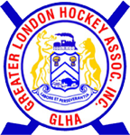
GLHA Agenda for
November 25 ,2021
- Welcome/Call to Order
- Confirmation of Agenda
- Mike Vandertuin –
- Keith Woods – Maltreatment
- Game Time discussion- Darcy Goettling 10-10-15 or 10-15-15?

- Approval of prior meeting minutes
- Reports;
  - Chairperson
  - Rep Council
  - London Referee Group
  - Treasurer
  - Technical Director
- Committee Reports;
  - Community Hockey League
  - Jr Mustangs
  - Championship
- Round Table/New Business
- Adjournment

